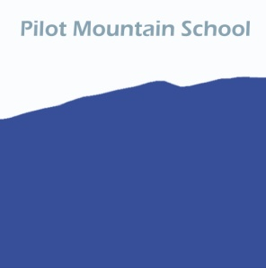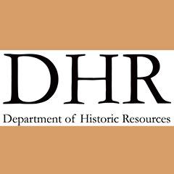

Oral History-Pilot Mountain School Questionnaire-VA DHR
- When did you attend Pilot Mountan School? What Years?
______________________________________________
- How do you know about Pilot Mountain School?
- ______________________________________________
- What did you study at Pilot Mountain School? (Reading, Math, Science) _________________________________________________
- How big were your classes there?
- _________________________________________________
- What grades were represented at Pilot Mountain School?
- ______________________________________________
- What was the school mascot and were there any athletics?
______________________________________________
- What were the school colors?
_____________________________________
- How long was the school year at Pilot Mountain School?
______________________________________

- Why was Pilot Mountain School significant in your life?
______________________________________________
- How did Pilot Mountain School change or shape your life?
______________________________________________
- Did you know that Pilot Mountain School currently offers an art station,
English, ESL, reading tutoring and MFRL “Little Libraries” program featuring
donated books that do not have to be returned?
_________________________________________________

*Please drop off at Pilot School or mail your response to:
WVArts
PO Box 64, Pilot VA 24138
Scan a copy and send to:
pilotmtnschool@outlook.com
Web Info:
http://pilotmtnschool.weebly.com

